Recursive Indexing Systems and Constraint-Preserving Representation Architectures
Substrate Core - Layer 1 Provisional Patent

Field of the Invention
The present disclosure relates generally to computational systems, artificial intelligence, representation learning, graph systems, biological modeling, and structured state-space computation.
More specifically, the disclosure relates to systems and methods in which indexing structures recursively generate transformation-preserving relational organizations across multiple scales, such that computation, representation formation, traversal, compression, and inference occur within recursively organized constraint-defined state spaces.
The disclosed systems may be implemented in software systems, hardware systems, biological modeling systems, machine learning architectures, hybrid symbolic-geometric systems, distributed computational systems, recursive planning systems, world-model architectures, and multi-agent inference systems.

Background of the Invention
Conventional computational systems typically rely on static indexing structures in which symbols, states, coordinates, or identifiers are mapped to predefined meanings, outputs, or locations.
Examples include:
- dictionaries mapping words to definitions,
- coordinate systems mapping values to positions,
- symbolic lookup tables,
- truth tables,
- embedding lookup systems,
- tokenization systems,
- database indexes,
- and codon tables mapping nucleotide triplets to amino acids.
These systems generally treat indexing as a first-order correlation process:
- symbol → meaning,
- coordinate → location,
- input → output.
Existing machine learning and artificial intelligence systems similarly rely on static indexing structures prior to learning. In many architectures:
- tokens are assigned identifiers,
- identifiers are mapped into embedding spaces,
- relationships are learned statistically during training.
As a result:
- structural organization is frequently discovered only after optimization begins,
- invalid or non-permissible states remain explorable during computation,
- representations may fail to preserve valid transformations,
- learning systems must independently learn many redundant relationships,
- and search complexity may grow combinatorially.
Existing systems also commonly separate:
- representation,
- indexing,
- geometry,
- constraint enforcement,
- and computation.
This separation produces systems in which:
- constraints are externally imposed,
- invalid states are generated and later filtered,
- and transformation validity is not intrinsically preserved during computation.
While some existing systems exploit symmetry or relational structure, including:
- graph neural networks,
- equivariant neural networks,
- manifold learning systems,
- and geometric learning architectures,
such systems generally operate after indexing has already been defined.
Accordingly, there exists a need for systems in which:
- indexing itself becomes recursively organized,
- valid transformations are structurally preserved,
- computation occurs within recursively generated constraint-defined state spaces,
- transformation spaces may be recursively compressed,
- and representations may emerge from recursively organized relational structure prior to learning.

Summary of the Invention
The present disclosure provides systems and methods for recursive indexing and recursive constraint-preserving representation generation.
In various embodiments, indexing is not treated merely as a static mapping between symbols and meanings, but as a recursively organized transformation-preserving relational architecture.
In contrast to conventional indexing systems, the disclosed systems recursively organize:
- symbols,
- states,
- neighborhoods,
- transformations,
- equivalence classes,
- adjacency structures,
- and reachability systems
into higher-order correlation structures.
In some embodiments:
- symbols generate neighborhoods,
- neighborhoods generate transformation systems,
- transformation systems generate higher-order relational organizations,
- and recursively generated organizations induce multi-scale computational geometries.
In various embodiments, recursive indexing systems preserve:
- transformation validity,
- structural consistency,
- constraint relationships,
- reachability,
- and relational coherence
across recursively organized layers.
The disclosed systems may:
- reduce computational complexity,
- reduce invalid state exploration,
- reduce independently learnable relationships,
- compress transformation spaces,
- improve transfer learning,
- improve representation stability,
- improve search efficiency,
- improve generalization,
- and improve multi-scale relational consistency.
In various embodiments, recursive indexing operates prior to embedding generation, manifold learning, optimization, or inference.
In some embodiments, recursive indexing defines a pre-embedding organizational layer configured to induce structured transformation-preserving geometry before statistical learning occurs.
In some embodiments, recursively generated structures define:
- valid computational trajectories,
- recursive reachability maps,
- recursive path systems,
- recursive equivalence classes,
- recursive compression systems,
- recursive representation systems,
- or recursive planning systems.
The disclosed systems may operate over:
- symbolic state spaces,
- graph-based state spaces,
- geometric state spaces,
- manifold-based systems,
- biological sequence systems,
- latent-space systems,
- distributed state systems,
- hybrid symbolic-geometric systems,
- or recursively composable multi-scale state spaces.

Core Definitions

Recursive Index
A recursive index is an indexing structure configured to recursively generate additional transformation-preserving relational organizations from one or more lower-order indexing structures.
Unlike static indexes that merely map symbols to meanings or locations, a recursive index generates higher-order structural relationships including:
- neighborhoods,
- adjacency structures,
- transformation classes,
- equivalence systems,
- reachability systems,
- recursive constraint systems,
- or recursively organized state spaces.

Constraint Structure
A constraint structure defines permissible relationships and transformations between states within a state space.
Constraint structures may include:
- adjacency constraints,
- symmetry constraints,
- topological constraints,
- relational constraints,
- biological constraints,
- geometric constraints,
- reachability constraints,
- equivalence constraints,
- or recursively generated constraints.
Constraint structures may be:
- explicit,
- implicit,
- learned,
- emergent,
- probabilistic,
- recursive,
- hierarchical,
- or dynamically updated.

Transformational Substrate
A transformational substrate comprises a primitive relational possibility space within which distinctions, neighborhoods, transformations, reachability relationships, and recursive organizational systems may emerge.
Different substrates naturally privilege different classes of:
- transformations,
- adjacency systems,
- symmetry relationships,
- traversal systems,
- recursive organizations,
- or computational grammars.
Examples may include:
- line-based substrates,
- graph substrates,
- sphere-based substrates,
- manifold substrates,
- symbolic substrates,
- geometric substrates,
- recursive relational substrates,
- or bounded transformational systems.
In some embodiments:
- recursive indexing operates over a bounded transformational substrate,
- recursively generated neighborhoods inherit substrate structure,
- and recursively induced geometry emerges from recursively preserved substrate relationships.

Transformation Neighborhood
A transformation neighborhood comprises a set of states reachable from one or more source states through permissible transformations defined by a constraint structure.
Neighborhoods may preserve:
- transformation validity,
- symmetry relationships,
- path structure,
- reachability,
- relational consistency,
- or recursive equivalence structure.

Recursive Transformation System
A recursive transformation system comprises a recursively organized set of transformation neighborhoods and constraint relationships configured to generate higher-order relational structures across multiple scales.
In some embodiments:
- lower-order neighborhoods generate higher-order neighborhoods,
- transformation systems recursively compose,
- recursively generated structures preserve reachability relationships,
- and recursive organizations induce computational geometry.

Bounded Recursive Primitive
A bounded recursive primitive comprises a compact relational system configured to recursively generate higher-order transformation-preserving structures through symmetry-preserving recursive operations.
In some embodiments:
- recursively generated structures induce adjacency systems,
- recursively generated neighborhoods preserve transformation relationships,
- recursively organized structures generate higher-order relational systems,
- and recursively generated geometry defines lawful traversal pathways.
Examples may include:
- recursive sphere systems,
- recursive polyhedral systems,
- recursive graph systems,
- recursively composable neighborhood systems,
- or recursively organized bounded geometries.

Recursive Compression
Recursive compression refers to reduction of effective transformation complexity through recursive organization of equivalence relationships, transformation neighborhoods, or constraint-preserving state reductions.
Recursive compression may:
- reduce independently learnable relationships,
- reduce invalid state exploration,
- reduce search complexity,
- preserve valid transformation structure,
- preserve reachability,
- preserve path relationships,
- preserve functional neighborhoods,
- or preserve recursive coherence across scales.

Recursive Reachability
Recursive reachability refers to recursively organized accessibility relationships between states within a recursively generated transformation system.
Reachability may include:
- valid path traversal,
- recursive path composition,
- hierarchical navigation,
- coarse-to-fine traversal,
- multi-scale connectivity,
- recursive planning trajectories,
- or recursively preserved navigation systems.

Recursive Representation Formation
Recursive representation formation refers to generation of representations from recursively organized constraint-preserving relational structures.
In some embodiments:
- representations emerge from recursively generated transformation systems,
- recursive indexing precedes embedding generation,
- representations preserve valid transformations,
- and recursively generated geometries define permissible computational operations.

Recursive Indexing Framework
In some embodiments, recursive indexing proceeds according to:
$I^{\left(k+1\right)}=R\left(I^{\left(k\right)},C^{\left(k\right)} \right)$
where:
- $I^{\left(k\right)}$ represents an indexing structure at recursive level $k$,
- $C^{\left(k\right)}$ represents a constraint structure associated with recursive level $k$,
- and $R$ represents a recursive organization operator configured to generate higher-order relational structures.
In some embodiments:
- recursive levels preserve transformation consistency,
- recursively generated neighborhoods induce higher-order geometry,
- recursively generated structures preserve valid traversal relationships,
- and recursive organization compresses transformation complexity.
In some embodiments, recursively organized transformation systems emerge from compact bounded relational primitives.
A bounded primitive may comprise:
- one or more recursively organized geometric objects,
- symmetry-preserving positioning systems,
- recursively generated neighborhood structures,
- recursively composable adjacency systems,
- or recursively induced transformation grammars.
In some embodiments:
- recursively generated neighborhoods become generators for additional neighborhoods,
- recursively generated structures induce higher-order geometry,
- recursively organized transformations generate lawful traversal systems,
- and recursively generated relational systems recursively induce additional transformation spaces.
In some embodiments:
- compact recursive primitives generate large structured transformation systems through recursively preserved symmetry operations.

Transformational Substrate Systems
In some embodiments, recursive indexing systems operate over bounded transformational substrates.
A transformational substrate defines:
- permissible neighborhoods,
- adjacency structure,
- equivalence relationships,
- transformation pathways,
- recursive reachability,
- or recursively composable organizational structure.
In some embodiments:
- different substrates privilege different transformation grammars,
- recursively generated neighborhoods inherit substrate geometry,
- recursively organized traversal systems preserve substrate structure,
- and recursive indexing amplifies substrate-defined relational organization across multiple scales.
Examples may include:
- line-based substrates,
- sphere-based substrates,
- recursive graph substrates,
- bounded geometric substrates,
- or recursively organized transformational systems.
In some embodiments:
- sphere-based substrates naturally preserve bounded neighborhoods, adjacency, rotational equivalence, and transformation closure.
In some embodiments:
- recursive indexing preserves substrate-defined transformation structure before embedding generation begins.

Representation Formation
In some embodiments, representations are generated according to:
$$R^{\left(k+1\right)}\left(x\right)=f\left(R^{\left(k\right)}\left(x\right),C^{\left(k\right)}\right)$$
where:
- $R^{\left(k\right)}\left(x\right)$ represents a representation at recursive level $k$,
- $C^{\left(k\right)}$ represents a recursive constraint structure,
- and $f$ represents a recursive representation-generation function.
In some embodiments:
- representations preserve valid transformations,
- recursively generated representations preserve reachability relationships,
- recursively generated geometries define permissible computation,
- and recursive representation systems reduce unconstrained exploration during inference or learning.

Recursive Artificial Intelligence Embodiments

Overview
In various embodiments, recursive indexing systems are applied to artificial intelligence architectures, machine learning systems, representation-learning systems, planning systems, inference systems, and world-model architectures.
Unlike conventional artificial intelligence systems in which:
- indexing is static,
- structure is learned only after optimization begins,
- and embeddings are generated prior to structural organization,
the disclosed systems recursively organize transformation-preserving relational structure prior to, during, or jointly with learning.
In some embodiments, recursive indexing defines a pre-embedding organizational architecture configured to:
- reduce transformation complexity,
- preserve valid relational structure,
- reduce invalid state exploration,
- improve transfer,
- improve coherence,
- improve sample efficiency,
- improve planning,
- or improve multi-scale representation consistency.

Pre-Embedding Recursive Organization
In some embodiments, recursive indexing operates prior to embedding generation.
In conventional machine learning architectures:
$input→tokenization→embedding→learned representation$
In various embodiments of the present disclosure:
$$input→recursive index→recursive neighborhood system→embedding→learned manifold$$
In some embodiments:
- symbols are recursively organized into transformation-preserving neighborhoods before embedding generation,
- recursive constraint systems define permissible relational organization,
- embeddings preserve recursively induced structure,
- and manifold learning occurs over recursively organized transformation systems.
In some embodiments, recursive indexing acts as:
- an inductive bias architecture,
- a recursive organization layer,
- a recursive manifold-conditioning layer,
- a recursive token-structuring layer,
- or a recursive latent initialization system.

Recursive Token Organization
In some embodiments, tokens are recursively organized according to:
- adjacency,
- symmetry,
- equivalence relationships,
- permissible transformations,
- reachability relationships,
- or recursively induced constraint systems.
Unlike conventional token systems in which tokens operate as independent identifiers, recursively indexed token systems may:
- preserve valid transformations,
- preserve neighborhood structure,
- recursively generate higher-order relational systems,
- or reduce independently learnable relationships.
In some embodiments:
- recursively organized token systems reduce token redundancy,
- recursively equivalent transformation classes are compressed,
- and recursive token organization improves transfer between tasks or domains.

Substrate-Aware Representation Systems
In some embodiments, representation systems are constructed over substrate-aware recursive indexing architectures.
Unlike conventional systems that treat symbols as relatively substrate-independent primitives, substrate-aware recursive systems preserve:
- substrate-defined adjacency,
- substrate-defined transformation structure,
- substrate-defined equivalence relationships,
- or substrate-defined traversal geometry.
In some embodiments:
- recursively organized substrates constrain representation formation,
- recursively generated neighborhoods preserve substrate-defined structure,
- and recursively induced geometry preserves lawful transformation systems prior to manifold learning.

Recursive Transformation Grammars
In some embodiments, recursively indexed systems operate as recursive transformation grammars.
Unlike static symbolic grammars, recursive transformation grammars:
- recursively generate lawful transformation systems,
- recursively preserve neighborhood structure,
- recursively organize equivalence relationships,
- and recursively induce higher-order relational geometry.
In some embodiments:
- recursively generated neighborhoods act as transformation-generating primitives,
- recursively organized transformations induce lawful traversal systems,
- and recursively generated structures recursively generate additional transformation systems across multiple scales.
Recursive transformation grammars may operate over:
- symbolic systems,
- graph systems,
- geometric systems,
- biological systems,
- latent systems,
- or recursively organized world-model systems.

Recursive Latent Geometry
In some embodiments, recursive indexing induces recursively organized latent geometry.
Unlike conventional latent spaces derived primarily from optimization or metric similarity, recursive latent geometries are induced from:
- recursively generated neighborhoods,
- recursive reachability systems,
- recursive equivalence classes,
- recursive constraint structures,
- or recursively composable valid transformations.
In some embodiments:
- latent geometry is derived from recursively preserved transformation structure,
- recursively generated paths define valid latent traversal,
- recursively generated neighborhoods define permissible inference trajectories,
- and recursive geometry constrains optimization and inference.
In various embodiments:
- geometry emerges from recursive transformation organization rather than unconstrained metric embedding.

Recursive World-Model Embodiments
In some embodiments, recursive indexing systems are applied to world-model architectures.
A world model may comprise:
- recursively indexed states,
- recursive reachability systems,
- recursive planning trajectories,
- recursively compressed transformation systems,
- or recursively generated latent environments.
In some embodiments:
- world states are recursively organized into valid transition neighborhoods,
- recursively induced geometry constrains prediction and planning,
- and recursive traversal systems define valid future-state generation.
In some embodiments:
- recursive indexing reduces exploration of invalid future trajectories,
- recursively compressed transformation systems reduce planning complexity,
- and recursively generated reachability maps support multi-scale navigation.
In some embodiments:
- coarse recursive levels define global planning structure,
- fine recursive levels define local execution structure,
- and recursively linked levels preserve path consistency across scales.

Recursive Planning Systems
In some embodiments, recursive indexing systems are configured for recursive planning and recursive navigation.
A recursive planning system may:
- recursively organize state spaces,
- recursively compress valid trajectories,
- recursively generate reachability systems,
- or recursively preserve navigational consistency across scales.
In some embodiments:
- planning occurs through recursive traversal of recursively organized neighborhoods,
- recursive coarsening reduces effective search complexity,
- recursively generated path systems preserve valid traversal relationships,
- and recursively compressed planning spaces reduce inference cost.
In some embodiments:
- recursive planning systems operate in robotics systems,
- autonomous navigation systems,
- multi-agent systems,
- reinforcement learning systems,
- simulation systems,
- or recursive decision architectures.

Recursive Transfer Learning
In some embodiments, recursive indexing systems support recursive transfer learning.
Unlike conventional transfer systems based primarily on:
- embedding similarity,
- feature reuse,
- or statistical alignment,
the disclosed systems transfer recursively organized constraint-preserving relational structure.
In some embodiments:
- recursive neighborhoods are transferred between domains,
- recursive equivalence structures are transferred across systems,
- recursive transformation classes are preserved across tasks,
- and recursively aligned constraint systems improve generalization.
In some embodiments:
- transfer compatibility depends on alignment of recursive constraint structure,
- recursively preserved valid transformations improve cross-domain transfer,
- and recursively induced geometries preserve meaningful traversal relationships between systems.
In some embodiments:
- recursive transfer systems are applied to biological sequence systems,
- language systems,
- robotics systems,
- world-model systems,
- or multi-modal systems.

Recursive Multi-Scale Representation Systems
In some embodiments, recursively indexed systems operate across multiple recursive scales.
In some embodiments:
- lower-order recursive systems preserve local transformations,
- higher-order recursive systems preserve global organization,
- and recursive connections preserve coherence between scales.
Recursive multi-scale systems may:
- preserve local consistency,
- preserve global coherence,
- reduce long-range inconsistency,
- improve abstraction formation,
- or improve hierarchical planning.
In some embodiments:
- recursively generated representations preserve path consistency across scales,
- recursively compressed structures preserve reachability,
- and recursively organized state systems support stable abstraction formation.

Recursive Inference Systems
In some embodiments, inference occurs through recursive traversal of recursively indexed transformation systems.
Unlike conventional inference systems that generate unconstrained candidate outputs followed by filtering, recursive inference systems:
- restrict inference to recursively permissible transformations,
- preserve recursive constraint relationships during inference,
- reduce invalid state generation,
- and preserve recursive reachability consistency.
In some embodiments:
- recursive inference reduces hallucination,
- recursively organized transformation systems improve stability,
- recursively constrained traversal reduces invalid state exploration,
- and recursive path systems preserve coherent inference trajectories.

Recursive Manifold Conditioning
In some embodiments, recursive indexing conditions manifold formation before or during optimization.
Rather than learning manifold geometry entirely through optimization, recursive indexing:
- pre-organizes relational structure,
- recursively induces transformation-preserving neighborhoods,
- recursively constrains latent geometry,
- or recursively initializes manifold structure.
In some embodiments:
- recursive manifold conditioning reduces optimization burden,
- recursive equivalence structures reduce redundancy,
- recursively preserved neighborhoods improve generalization,
- and recursively induced geometry improves transfer consistency.

Recursive Equivalence Systems
In some embodiments, recursive indexing systems recursively organize equivalence relationships between states.
Equivalence systems may include:
- transformation equivalence,
- functional equivalence,
- navigational equivalence,
- symmetry equivalence,
- or recursively induced equivalence classes.
In some embodiments:
- recursively equivalent states are compressed into shared transformation systems,
- recursive equivalence reduces independently learnable relationships,
- and recursive equivalence structures reduce effective search complexity.

Recursive Graph-Based AI Systems
In some embodiments, recursively indexed systems operate over graph-based architectures.
Graphs may include:
- recursive adjacency systems,
- recursively generated neighborhood graphs,
- recursive reachability graphs,
- recursively compressed graph systems,
- or recursive path-preserving graph structures.
In some embodiments:
- graph traversal preserves recursive transformation validity,
- recursively generated graph systems preserve multi-scale connectivity,
- and recursive graph organization supports efficient planning and inference.

Recursive Hybrid Symbolic-Geometric Systems
In some embodiments, recursive indexing systems integrate:
- symbolic systems,
- geometric systems,
- relational systems,
- graph systems,
- and recursive transformation systems.
In some embodiments:
- symbolic representations define lower-order indexing,
- recursive indexing generates higher-order relational geometry,
- recursively generated geometries define permissible computation,
- and recursive traversal systems integrate symbolic and geometric inference.
Such systems may operate in:
- artificial intelligence systems,
- reasoning systems,
- scientific modeling systems,
- biological modeling systems,
- autonomous systems,
- or recursively composable computational architectures.

Recursive Biological Embodiments

Overview
In various embodiments, recursive indexing systems are applied to biological systems, sequence systems, mutational systems, genetic systems, protein systems, cellular systems, evolutionary systems, and biological representation architectures.
Unlike conventional biological representations that treat biological systems primarily as static symbolic mappings, the disclosed systems represent biological organization as recursively organized transformation-preserving relational structure.
In some embodiments:
- biological states are recursively organized into transformation neighborhoods,
- recursive constraint systems preserve biologically permissible transitions,
- recursively induced geometry defines biological reachability,
- and recursively organized representations preserve functional transformation structure across scales.
In some embodiments:
- recursive biological indexing operates prior to statistical learning,
- recursively generated biological structure constrains representation formation,
- and recursively organized transformation systems reduce biological search complexity.

Recursive Codon Systems
In some embodiments, recursive indexing systems operate over codon systems.
Conventional codon representations typically define:
- codon → amino acid mappings.
In various embodiments of the present disclosure:
- codons are recursively organized into transformation-preserving neighborhoods,
- recursive codon neighborhoods define permissible biological transformations,
- recursively generated codon systems preserve mutational structure,
- and recursive codon organization induces biological geometry.
In some embodiments:
- codons are represented as states within recursively organized transformation systems,
- transitions correspond to biologically permissible mutations,
- recursive neighborhoods preserve mutational adjacency,
- and recursively induced geometry defines valid traversal relationships.
In some embodiments:
- codon neighborhoods recursively compose into higher-order transformation systems,
- recursively generated codon structures preserve biological asymmetries,
- and recursive organization preserves mutation-class structure.

Biological Constraint Structures
In some embodiments, recursive biological systems are governed by biological constraint structures.
Constraint structures may include:
- positional constraints,
- mutation-class constraints,
- transition/transversion asymmetries,
- synonymous mutation structure,
- wobble constraints,
- biochemical constraints,
- folding constraints,
- energetic constraints,
- functional constraints,
- or recursively generated biological constraints.
In some embodiments:
- biological constraint structures define permissible transformations,
- recursively generated biological neighborhoods preserve functional organization,
- and recursively induced geometry constrains biological traversal systems.
In some embodiments:
- biological geometry emerges from recursively organized valid transformations rather than from predefined metrics.

Recursive Mutation Neighborhoods
In some embodiments, mutations are represented as recursively organized transformation systems.
In some embodiments:
- a mutation defines traversal between biologically related states,
- recursive mutation neighborhoods preserve valid biological transformations,
- recursively organized mutation systems preserve reachability,
- and recursively induced path systems define biologically meaningful traversal trajectories.
Mutation neighborhoods may preserve:
- positional structure,
- mutation-type structure,
- functional neighborhoods,
- synonymous neighborhoods,
- energetic compatibility,
- or recursively preserved biological equivalence relationships.

Recursive Biological Geometry
In some embodiments, recursive indexing induces recursively organized biological geometry.
Unlike conventional biological embeddings derived primarily from similarity metrics or statistical optimization, recursive biological geometry is induced from:
- recursively preserved transformation systems,
- recursively generated mutation neighborhoods,
- recursive reachability systems,
- recursive biological constraints,
- or recursively induced valid biological traversal.
In some embodiments:
- biological geometry preserves mutational validity,
- recursively induced geometry preserves functional reachability,
- recursive biological path systems preserve biological consistency,
- and recursively generated geometry defines biologically permissible transitions.
In some embodiments:
- locally valid biological regions are recursively linked through sparse biologically permissible bridges,
- recursive geometry defines piecewise-flat biological regions,
- and recursively generated boundaries preserve biological constraint structure.

Recursive Functional Neighborhoods
In some embodiments, recursive indexing systems preserve functional biological neighborhoods.
Functional neighborhoods may include:
- mutation neighborhoods,
- protein-function neighborhoods,
- synonymous neighborhoods,
- structural equivalence neighborhoods,
- fitness neighborhoods,
- or recursively induced biological equivalence systems.
In some embodiments:
- recursively generated biological neighborhoods preserve functional coherence,
- recursive neighborhood organization reduces biological search complexity,
- recursively organized biological systems preserve valid functional transformations,
- and recursive biological neighborhoods support biological transfer learning.

Recursive Protein Representation Systems
In some embodiments, proteins are represented using recursively organized constraint-preserving systems.
In some embodiments:
- protein sequence space is recursively organized according to functional constraint structure,
- recursively generated neighborhoods preserve mutation sensitivity structure,
- recursive representation systems preserve functional transformations,
- and recursively induced geometry defines biologically meaningful traversal relationships.
In some embodiments:
- recursively generated protein representations preserve mutation propagation structure,
- recursive organization preserves sensitivity relationships across positions,
- and recursive biological geometry supports transfer between related systems.

Recursive Transfer-Compatibility Systems
In some embodiments, recursive indexing systems define transfer compatibility between biological systems.
Unlike conventional transfer systems based primarily on:
- sequence identity,
- embedding similarity,
- or statistical proximity,
the disclosed systems evaluate transfer compatibility according to alignment of recursively organized functional constraint structure.
In some embodiments:
- recursively preserved biological transformations are transferred between systems,
- recursive neighborhood alignment predicts transfer compatibility,
- recursively induced biological geometry determines preservation of valid transformations,
- and recursively aligned constraint systems improve cross-system generalization.
In some embodiments:
- transfer success depends on preservation of recursively organized functional neighborhoods,
- recursively preserved sensitivity structure defines biologically meaningful transfer,
- and recursive biological representations preserve transformation validity across systems.

Recursive Sensitivity Structures
In some embodiments, recursively organized biological systems preserve site-level sensitivity structure.
Sensitivity structures may define:
- positional importance,
- functional propagation,
- mutation relevance,
- recursively preserved biological constraints,
- or recursively induced functional organization.
In some embodiments:
- recursively organized sensitivity systems preserve biologically meaningful transformations,
- recursively aligned sensitivity structures improve transfer,
- and recursive sensitivity geometry predicts biological compatibility relationships.

Recursive Biological Compression
In some embodiments, recursive biological indexing reduces biological transformation complexity.
Recursive biological compression may:
- reduce independently learnable mutation relationships,
- reduce biological search complexity,
- preserve biologically valid transformations,
- preserve functional reachability,
- preserve recursive biological equivalence classes,
- or preserve recursive biological coherence.
In some embodiments:
- recursively equivalent mutations are compressed into shared transformation systems,
- recursively organized biological neighborhoods reduce representation redundancy,
- and recursively generated biological geometry compresses effective traversal space.

Recursive Evolutionary Systems
In some embodiments, recursive indexing systems model evolutionary systems.
Evolutionary systems may include:
- recursively organized mutation trajectories,
- recursive reachability systems,
- recursively constrained fitness traversal,
- recursive functional landscapes,
- or recursively generated adaptive pathways.
In some embodiments:
- evolutionary traversal occurs within recursively constrained biological geometry,
- recursive biological neighborhoods define valid evolutionary trajectories,
- recursively induced geometry preserves functional reachability,
- and recursive compression reduces effective evolutionary search complexity.

Recursive Multi-Scale Biological Organization
In some embodiments, recursive biological systems operate across multiple biological scales.
Recursive scales may include:
- nucleotide systems,
- codon systems,
- amino acid systems,
- protein systems,
- pathway systems,
- cellular systems,
- or recursively composable biological organizations.
In some embodiments:
- lower-order biological constraints generate higher-order biological organization,
- recursively generated biological geometry preserves coherence across scales,
- recursive biological systems preserve transformation consistency between scales,
- and recursively organized biological systems support stable multi-scale representation.

Recursive Biological Path Systems
In some embodiments, recursively organized biological systems define recursive path structures.
Biological paths may include:
- mutation trajectories,
- evolutionary trajectories,
- folding trajectories,
- functional traversal paths,
- recursive biological navigation systems,
- or recursively generated adaptive pathways.
In some embodiments:
- recursive biological path systems preserve valid traversal relationships,
- recursively generated biological geometry defines permissible biological navigation,
- and recursively preserved reachability systems support prediction of biological transformation outcomes.

Recursive Biological Inference
In some embodiments, biological inference occurs through recursive traversal of recursively indexed biological state spaces.
Unlike systems that generate unconstrained biological predictions followed by filtering, recursively indexed biological systems:
- preserve biological validity during inference,
- reduce invalid biological traversal,
- preserve recursively defined functional neighborhoods,
- and preserve recursively generated biological reachability structure.
In some embodiments:
- recursively constrained biological inference improves biological prediction stability,
- recursive biological organization improves transfer generalization,
- and recursively organized biological geometry improves preservation of biologically meaningful transformations.

Recursive Compression And Coarsening Systems

Overview
In various embodiments, recursive indexing systems perform recursive compression, recursive coarsening, recursive state reduction, recursive equivalence organization, and recursive path-preserving transformation-space reduction.
Unlike conventional compression systems that primarily reduce storage or dimensionality, the disclosed systems recursively compress transformation structure while preserving:
- valid traversal relationships,
- reachability,
- functional neighborhoods,
- transformation equivalence,
- recursive connectivity,
- or multi-scale coherence.
In some embodiments:
- recursive compression reduces effective computational complexity,
- recursively organized equivalence systems reduce independently learnable relationships,
- recursively generated coarsened structures preserve valid traversal geometry,
- and recursive state reduction preserves constraint-consistent computation.

Recursive Transformation-Space Compression
In some embodiments, recursive indexing compresses transformation space.
Transformation-space compression may include:
- recursive equivalence reduction,
- recursive neighborhood merging,
- recursive symmetry preservation,
- recursive state-space collapse,
- recursive redundancy reduction,
- or recursive path-preserving abstraction.
In some embodiments:
- multiple transformation systems are recursively represented through shared higher-order structure,
- recursively equivalent transformations are compressed into recursively organized equivalence classes,
- and recursive organization reduces effective traversal complexity.
In some embodiments:
- recursive transformation-space compression reduces search complexity,
- reduces optimization burden,
- reduces independently learnable relationships,
- or reduces invalid state exploration.

Recursive Equivalence Classes
In some embodiments, recursive indexing systems recursively organize equivalence relationships.
Equivalence classes may include:
- transformation equivalence,
- navigational equivalence,
- functional equivalence,
- geometric equivalence,
- biological equivalence,
- or recursively induced relational equivalence.
In some embodiments:
- recursively equivalent states are compressed into shared transformation systems,
- recursive equivalence classes preserve reachability relationships,
- recursive organization preserves valid traversal structure,
- and recursively organized equivalence systems reduce effective state-space complexity.
In some embodiments:
- equivalence relationships operate across multiple recursive scales,
- recursively generated equivalence systems preserve local and global consistency,
- and recursively induced equivalence systems support transfer between domains.

Recursive Coarsening
In some embodiments, recursive indexing systems recursively coarsen state spaces.
Recursive coarsening may include:
- graph coarsening,
- recursive neighborhood abstraction,
- recursive region formation,
- hierarchical state collapse,
- recursive topology reduction,
- or recursive path-preserving abstraction.
Unlike arbitrary dimensionality reduction systems, recursively coarsened systems preserve:
- valid transformation structure,
- recursive reachability,
- navigational consistency,
- path structure,
- recursive connectivity,
- or recursively preserved constraint organization.
In some embodiments:
- lower-order neighborhoods are recursively merged into higher-order relational systems,
- recursively generated regions preserve valid traversal,
- and recursively organized abstraction layers preserve multi-scale structure.

Path-Preserving Compression
In some embodiments, recursive compression preserves path structure.
Path-preserving systems may preserve:
- shortest-path relationships,
- recursive reachability,
- traversal validity,
- navigational continuity,
- recursive connectivity,
- or recursively valid transformation trajectories.
In some embodiments:
- recursively compressed structures preserve valid traversal between states,
- recursively generated abstraction layers preserve navigational accessibility,
- and recursive coarsening preserves meaningful transformation pathways.
In some embodiments:
- recursively compressed systems preserve path fidelity between fine and coarse scales,
- recursive traversal systems preserve transformation consistency,
- and recursively generated navigation systems preserve valid planning trajectories.

Recursive Reachability Systems
In some embodiments, recursive indexing systems define recursively organized reachability relationships.
Reachability systems may include:
- recursive traversal maps,
- recursive navigation systems,
- recursive planning systems,
- recursive path composition,
- hierarchical connectivity systems,
- or recursively generated accessibility structures.
In some embodiments:
- recursively generated reachability systems preserve valid traversal under recursive compression,
- recursively induced geometry preserves accessibility relationships across scales,
- and recursive coarsening preserves navigational consistency.

Multi-Scale Recursive Navigation
In some embodiments, recursive indexing supports multi-scale navigation.
In some embodiments:
- coarse recursive levels define large-scale traversal organization,
- fine recursive levels define local traversal behavior,
- recursively linked scales preserve navigational consistency,
- and recursive traversal systems support coarse-to-fine planning.
In some embodiments:
- recursively compressed systems support efficient global planning,
- recursively refined systems support local execution,
- and recursive organization preserves consistency between abstraction layers.

Recursive Graph Compression
In some embodiments, recursively indexed systems operate over graph structures.
Recursive graph compression may include:
- recursive node aggregation,
- recursive edge abstraction,
- recursive neighborhood merging,
- recursive graph simplification,
- or recursively induced hierarchical graph systems.
In some embodiments:
- recursively compressed graphs preserve adjacency structure,
- recursive graph systems preserve reachability,
- recursive graph compression preserves navigational validity,
- and recursively generated graph abstractions preserve transformation consistency.
In some embodiments:
- recursively generated graph systems preserve local and global structure simultaneously,
- and recursive graph organization supports efficient traversal and planning.

Recursive Manifold Reduction
In some embodiments, recursive indexing recursively reduces manifold complexity.
Recursive manifold reduction may:
- compress latent geometry,
- preserve recursively valid transformation systems,
- preserve recursively induced neighborhoods,
- preserve recursive reachability,
- or preserve recursively generated equivalence structure.
Unlike unconstrained manifold reduction systems, recursive manifold reduction preserves:
- transformation validity,
- recursive relational consistency,
- and recursively organized traversal geometry.

Recursive Search Reduction
In some embodiments, recursive indexing systems reduce effective search complexity.
Recursive search reduction may include:
- recursive pruning of invalid states,
- recursive transformation compression,
- recursive reachability restriction,
- recursive equivalence organization,
- or recursively constrained traversal systems.
In some embodiments:
- recursive organization reduces combinatorial explosion,
- recursively generated equivalence systems reduce independently searchable relationships,
- and recursively constrained traversal systems reduce invalid exploration.
In some embodiments:
- recursively organized search systems preserve valid transformation structure while reducing effective traversal space.

Recursive Hierarchical State Spaces
In some embodiments, recursive indexing systems generate recursively organized hierarchical state spaces.
Hierarchical systems may include:
- recursively nested regions,
- recursively composable neighborhoods,
- recursive abstraction layers,
- recursively linked traversal systems,
- or recursively induced multi-scale geometry.
In some embodiments:
- recursively generated higher-order regions preserve lower-order transformation validity,
- recursive hierarchy preserves navigational consistency across scales,
- and recursively generated abstraction systems support scalable computation.

Recursive World-Model Compression
In some embodiments, recursive compression systems operate within world-model architectures.
In some embodiments:
- recursively compressed world models preserve valid future-state reachability,
- recursively organized planning systems reduce future-state exploration complexity,
- recursively generated abstraction systems preserve navigational validity,
- and recursive compression supports efficient latent traversal.
In some embodiments:
- recursively compressed latent systems preserve valid environmental transitions,
- recursively induced geometry constrains planning,
- and recursively organized abstraction systems improve world-model scalability.

Recursive Biological Compression
In some embodiments, recursive compression systems operate over biological state spaces.
Biological recursive compression may include:
- recursive mutation-space compression,
- recursive protein neighborhood reduction,
- recursive functional equivalence organization,
- recursive sensitivity abstraction,
- or recursively induced biological traversal systems.
In some embodiments:
- recursively equivalent biological transformations are compressed into shared systems,
- recursive biological compression preserves functional reachability,
- and recursively generated biological abstractions preserve biologically valid traversal.

Recursive Representation Abstraction
In some embodiments, recursive indexing systems recursively abstract representations across multiple scales.
Recursive abstraction may preserve:
- valid transformations,
- recursive reachability,
- recursive neighborhood structure,
- recursively induced geometry,
- or recursive relational coherence.
In some embodiments:
- recursively generated abstraction systems preserve transformation validity while reducing representation complexity,
- recursively linked representations preserve consistency across abstraction layers,
- and recursively induced representation geometry supports scalable inference and planning.

Recursive Path Consistency
In some embodiments, recursively indexed systems preserve recursive path consistency.
Recursive path consistency may include:
- preservation of valid traversal relationships,
- preservation of recursive navigation structure,
- preservation of recursively generated planning trajectories,
- or preservation of recursively induced connectivity.
In some embodiments:
- recursively compressed systems preserve valid transformation pathways across abstraction scales,
- recursive coarsening preserves navigational continuity,
- and recursively organized traversal systems maintain coherent reachability relationships.

Claims

Independent Claim 1 — Recursive Indexing System
- A computational system comprising:
a. a structured state space comprising a plurality of states;
b. a constraint structure defining permissible relationships and transformations between the states;
c. a recursive indexing engine configured to recursively organize the states into transformation-preserving relational structures across multiple recursive levels;
d. one or more transformation operators configured to transition between states according to the constraint structure; and
e. a computation engine configured to perform computation through traversal of the recursively organized relational structures subject to the constraint structure;
wherein:
(i) recursive indexing generates higher-order relational organizations from lower-order indexing structures;
(ii) recursively generated relational structures preserve permissible transformation relationships;
(iii) recursively organized structures define permissible computational traversal; and
(iv) computation is constrained by recursively preserved transformation validity.

Independent Claim 2 — Method
- A method for performing recursive constraint-preserving computation, comprising:
a. representing a plurality of states within a structured state space;
b. defining a constraint structure governing permissible transformations between the states;
c. recursively organizing the states into transformation-preserving relational structures across multiple recursive levels;
d. generating recursively organized neighborhoods comprising reachable states defined by permissible transformations;
e. traversing the recursively organized neighborhoods according to the constraint structure; and
f. producing a computational output corresponding to a state reached through recursively permissible transformations;
wherein recursive organization reduces invalid state exploration while preserving valid traversal relationships.

Independent Claim 3 — Computer-Readable Medium
- A non-transitory computer-readable medium storing instructions that, when executed by one or more processors, cause the one or more processors to:
a. represent a plurality of states within a structured state space;
b. define a recursive constraint structure governing permissible transformations between the states;
c. recursively generate transformation-preserving relational organizations across multiple recursive levels;
d. recursively organize states into transformation neighborhoods;
e. perform computation through traversal of recursively organized transformation neighborhoods; and
f. output a computational result corresponding to recursively permissible traversal within the structured state space.

Independent Claim 4 — Pre-Embedding Recursive Representation System
- A representation-generation system comprising:
a. an input system configured to receive symbolic, relational, biological, geometric, or graph-based inputs;
b. a recursive indexing layer configured to recursively organize the inputs into transformation-preserving neighborhoods prior to embedding generation;
c. a recursive constraint structure governing permissible relationships between recursively organized neighborhoods;
d. an embedding generation system configured to generate embeddings from the recursively organized neighborhoods; and
e. a learning system configured to operate over the embeddings;
wherein:
(i) recursive indexing precedes embedding generation;
(ii) recursively generated neighborhoods preserve valid transformation structure;
(iii) recursively organized relational structures constrain representation formation; and
(iv) recursively organized transformation-preserving structure reduces independently learnable relationships.

Independent Claim 5 — Recursive Compression System
- A recursive compression system comprising:
a. a structured state space comprising states connected through permissible transformations;
b. a recursive equivalence engine configured to recursively organize states into equivalence structures according to transformation relationships;
c. a recursive coarsening engine configured to recursively compress the structured state space into higher-order abstraction layers; and
d. a traversal system configured to preserve valid reachability relationships during recursive compression;
wherein:
(i) recursive compression preserves permissible traversal structure;
(ii) recursively compressed structures preserve reachability relationships across recursive levels;
(iii) recursive compression reduces effective transformation-space complexity; and
(iv) recursively organized equivalence systems reduce independently searchable relationships.

Independent Claim 6 — World-Model System
- A world-model architecture comprising:
a. a recursively organized state space representing environmental states;
b. a recursive constraint structure governing permissible environmental transitions;
c. a recursive planning engine configured to recursively generate reachability systems across multiple abstraction scales;
d. a recursive traversal engine configured to navigate recursively organized state structures; and
e. a prediction system configured to generate future-state predictions subject to recursively preserved transformation validity;
wherein:
(i) recursive indexing reduces invalid future-state exploration;
(ii) recursively organized abstraction systems preserve valid planning trajectories;
(iii) recursively generated geometry constrains prediction and planning; and
(iv) recursively compressed state systems reduce planning complexity.

Independent Claim 7 — Biological Representation System
- A biological modeling system comprising:
a. a biological state space comprising biological sequence elements;
b. a biological constraint structure defining permissible biological transformations between the sequence elements;
c. a recursive indexing engine configured to recursively organize biological states into transformation-preserving biological neighborhoods;
d. a recursive biological representation system configured to preserve recursively organized functional transformation structure; and
e. a biological inference engine configured to perform biological prediction through traversal of recursively organized biological neighborhoods;
wherein:
(i) recursively organized biological neighborhoods preserve biologically permissible transformations;
(ii) recursively induced biological geometry defines biologically valid traversal relationships;
(iii) recursive biological organization preserves functional neighborhood structure; and
(iv) recursively preserved biological constraint structures improve biological transfer generalization.

Dependent Claims

Recursive Structure Claims
- The system of claim 1, wherein recursive indexing generates recursively composable neighborhoods across multiple recursive scales.
- The system of claim 1, wherein recursively generated neighborhoods preserve adjacency relationships.
- The system of claim 1, wherein recursively generated structures preserve reachability relationships.
- The system of claim 1, wherein recursive organization induces multi-scale geometry.
- The system of claim 1, wherein recursively generated structures define valid computational trajectories.

Compression Claims
- The system of claim 5, wherein recursive compression preserves shortest-path relationships.
- The system of claim 5, wherein recursive compression preserves navigational consistency across recursive abstraction levels.
- The system of claim 5, wherein recursive coarsening preserves spectral properties of the structured state space.
- The system of claim 5, wherein recursive compression preserves path fidelity between abstraction scales.
- The system of claim 5, wherein recursively equivalent transformations are compressed into shared transformation systems.

AI Claims
- The system of claim 4, wherein recursively organized neighborhoods define latent-space geometry.
- The system of claim 4, wherein recursive indexing acts as a pre-embedding inductive bias architecture.
- The system of claim 4, wherein recursively organized representations preserve valid transformation relationships during optimization.
- The system of claim 4, wherein recursive organization improves transfer learning between domains.
- The system of claim 4, wherein recursive indexing reduces hallucination during inference.

World-Model Claims
- The system of claim 6, wherein recursive abstraction layers support coarse-to-fine planning.
- The system of claim 6, wherein recursively compressed traversal systems preserve valid future-state reachability.
- The system of claim 6, wherein recursively generated planning systems preserve path consistency across recursive scales.
- The system of claim 6, wherein recursively constrained traversal reduces environmental search complexity.

Biological Claims
- The system of claim 7, wherein biological transformations comprise mutations between codons.
- The system of claim 7, wherein recursive biological neighborhoods preserve synonymous mutation structure.
- The system of claim 7, wherein recursive biological organization preserves positional mutation asymmetry.
- The system of claim 7, wherein recursively organized biological systems preserve functional sensitivity structure.
- The system of claim 7, wherein recursive biological transfer depends on alignment of recursively organized constraint structure.
- The system of claim 7, wherein recursively organized biological geometry preserves biologically permissible traversal relationships.

Graph and Geometry Claims
- The system of claim 1, wherein the structured state space comprises a graph-based representation.
- The system of claim 1, wherein recursively organized structures comprise recursive adjacency graphs.
- The system of claim 1, wherein recursively generated geometry is derived from permissible transformations rather than metric distance.
- The system of claim 1, wherein recursively generated relational structures comprise recursively induced equivalence classes.

Multi-Agent and Knowledge-State Claims
- The system of claim 1, wherein recursively organized state structures model recursive knowledge relationships between agents.
- The system of claim 1, wherein recursive reachability preserves recursive inference consistency across multiple agents.
- The system of claim 1, wherein recursively organized structures define recursive epistemic state spaces.

Hardware and Distributed Claims
- The system of claim 1, wherein recursively organized computation is distributed across multiple computing systems.
- The system of claim 1, wherein recursively organized traversal is implemented in specialized hardware.
- The system of claim 1, wherein recursive transformation systems operate within multi-state processor architectures.

General Scope Clause
- The systems and methods of any preceding claim, wherein recursive indexing operates over symbolic systems, graph systems, geometric systems, manifold systems, biological systems, latent-space systems, world-model systems, planning systems, or hybrid symbolic-geometric systems.
- The systems and methods of any preceding claim, wherein recursively organized relational structures preserve valid transformation relationships across multiple recursive scales.
- The systems and methods of any preceding claim, wherein computation is defined through recursively constrained traversal within recursively organized transformation-preserving state spaces.

Figure Descriptions

FIGURE 1 — Recursive Indexing Architecture
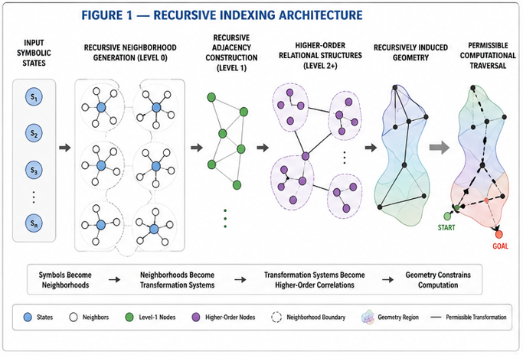
Figure 1 illustrates a recursive indexing pipeline in which:
- symbolic inputs are recursively organized into transformation-preserving neighborhoods,
- recursively organized neighborhoods generate higher-order relational structures,
- recursively generated relational structures induce recursively organized geometry,
- and recursively induced geometry defines permissible computational traversal.
In some embodiments:
- symbols become neighborhoods,
- neighborhoods become transformation systems,
- transformation systems become recursively generated correlation structures,
- and recursively organized geometry constrains computation.
Figure 1 may illustrate:
- symbolic states,
- neighborhood formation,
- recursive adjacency generation,
- recursive reachability systems,
- recursive equivalence systems,
- or recursively induced transformation geometry.

FIGURE 2 — Pre-Embedding Recursive AI System
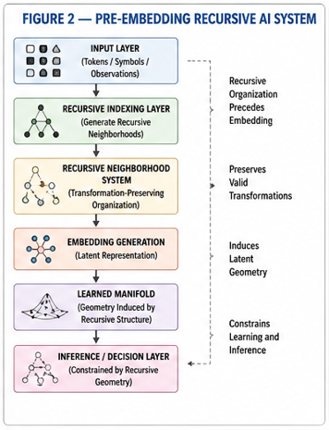
Figure 2 illustrates an artificial intelligence architecture comprising:
- an input layer,
- a recursive indexing layer,
- a recursive neighborhood-generation layer,
- an embedding-generation layer,
- a learned manifold layer,
- and an inference layer.
In some embodiments:
- recursive indexing precedes embedding generation,
- recursively generated neighborhoods preserve transformation structure,
- recursively organized latent geometry constrains learning,
- and recursively induced structure reduces independently learnable relationships.
Figure 2 may illustrate:
- recursive token organization,
- recursive latent conditioning,
- recursive manifold initialization,
- recursive transfer systems,
- or recursively constrained inference.

FIGURE 3 — Recursive Coarsening and Path Preservation
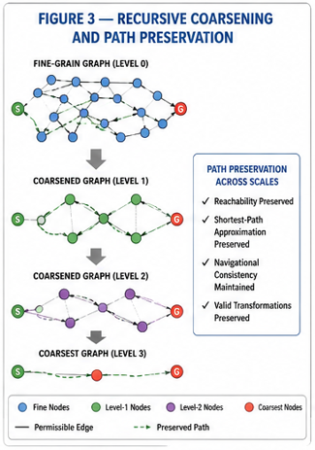
Figure 3 illustrates recursive coarsening of a structured state space.
In some embodiments:
- lower-order neighborhoods are recursively merged into higher-order abstraction regions,
- recursively compressed structures preserve valid traversal,
- recursively generated abstraction systems preserve reachability,
- and recursive path systems preserve navigational consistency.
Figure 3 may illustrate:
- fine-scale graphs,
- recursively coarsened graphs,
- preserved traversal pathways,
- preserved shortest paths,
- recursive reachability systems,
- or hierarchical navigation systems.

FIGURE 4 — Recursive Biological Indexing System
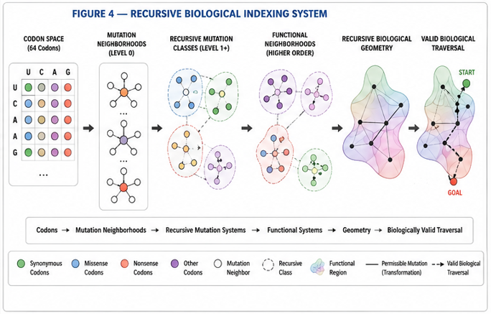
Figure 4 illustrates recursive indexing over biological sequence systems.
In some embodiments:
- codons define lower-order biological states,
- mutations define permissible transformations,
- recursively generated mutation neighborhoods preserve biological structure,
- and recursively induced biological geometry defines biologically valid traversal relationships.
Figure 4 may illustrate:
- codon neighborhoods,
- mutation classes,
- synonymous neighborhoods,
- recursive biological equivalence systems,
- recursive mutation reachability,
- or recursively organized functional neighborhoods.

FIGURE 5 — Recursive World-Model Planning System
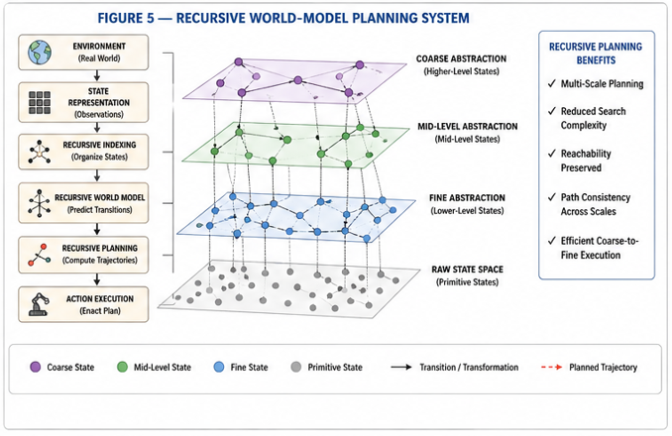
Figure 5 illustrates recursive planning within recursively organized world-model architectures.
In some embodiments:
- recursively organized states preserve environmental transition structure,
- recursively compressed abstraction systems reduce planning complexity,
- recursively generated reachability systems support navigation,
- and recursive path-preserving traversal enables multi-scale planning.
Figure 5 may illustrate:
- hierarchical planning systems,
- recursive reachability maps,
- coarse-to-fine traversal,
- recursive planning trajectories,
- recursive latent navigation,
- or recursively compressed future-state systems.

FIGURE 6 — Recursive Generative Primitive System
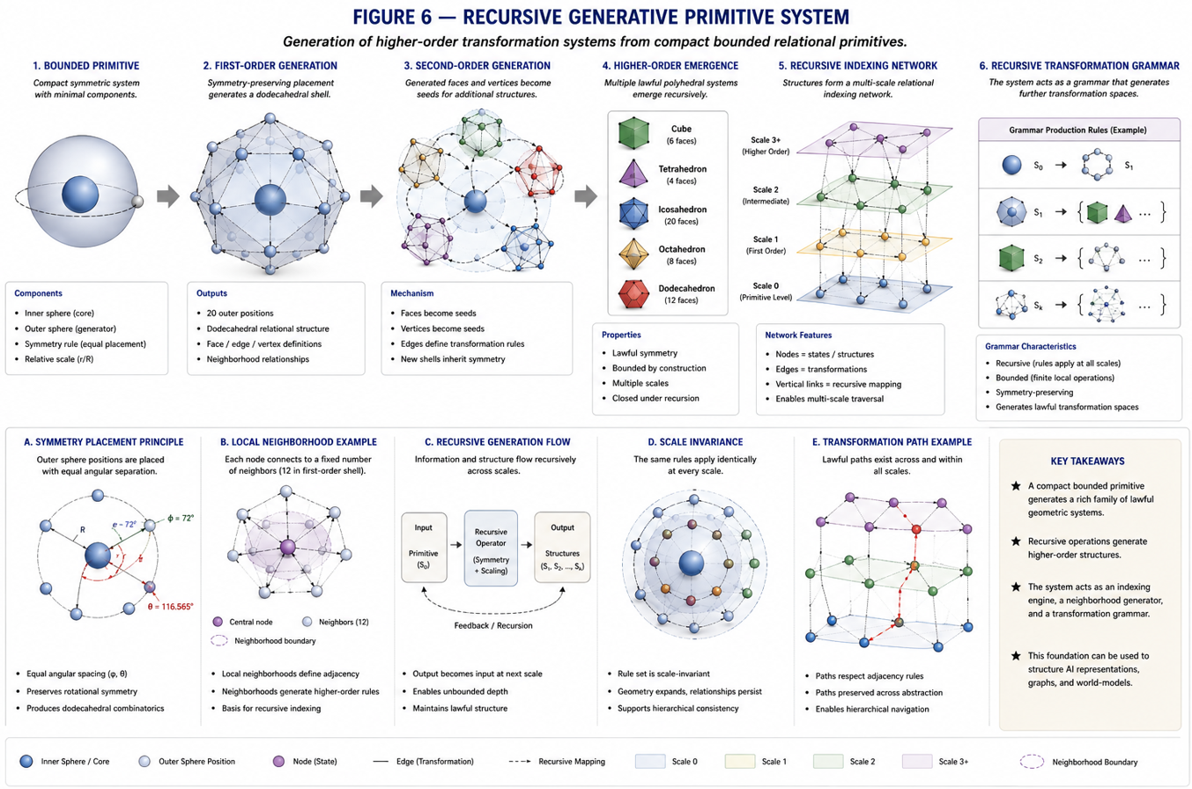
Figure 6 illustrates recursive generation of higher-order transformation systems from compact bounded relational primitives.
In some embodiments:
- recursively organized sphere systems generate higher-order adjacency systems,
- recursively generated relational structures induce recursive equivalence systems,
- recursively organized neighborhoods recursively generate additional transformation spaces,
- and recursively induced geometry defines lawful traversal pathways.
Figure 6 may illustrate:
- recursive sphere systems,
- recursive polyhedral emergence,
- recursive neighborhood generation,
- recursively generated adjacency systems,
- recursive transformation grammars,
- or recursively induced multi-scale geometry.

FIGURE 7 — Transformational Substrate Systems
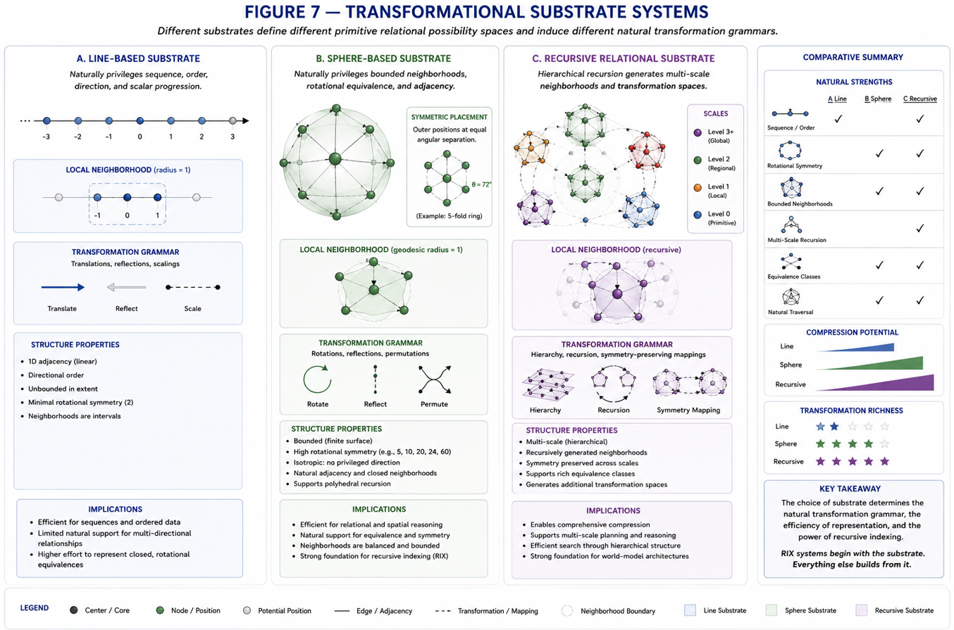
Figure 7 illustrates multiple classes of transformational substrates and their associated recursive organizational properties.
In some embodiments, a transformational substrate defines the primitive relational possibility space within which:
- distinctions,
- neighborhoods,
- transformations,
- adjacency systems,
- equivalence relationships,
- reachability pathways,
- and recursive organizational structures
may emerge.
Figure 7 illustrates that different substrates naturally privilege different classes of:
- transformation grammars,
- neighborhood systems,
- recursive organizations,
- traversal systems,
- and compressibility properties.
In some embodiments, the figure compares:
- line-based substrates,
- sphere-based substrates,
- and recursive relational substrates.
In some embodiments:
Line-Based Substrates
Line-based substrates preserve:
- directional order,
- scalar progression,
- sequential traversal,
- and coordinate-defined adjacency.
In some embodiments:
- neighborhoods are interval-based,
- transformations preserve directional structure,
- and traversal occurs primarily through ordered progression.
Sphere-Based Substrates
Sphere-based substrates preserve:
- bounded neighborhoods,
- rotational equivalence,
- adjacency closure,
- and symmetry-preserving traversal.
In some embodiments:
- neighborhoods emerge from geodesic or rotational organization,
- transformations preserve bounded relational structure,
- and recursive organization supports lawful multi-directional traversal.
In some embodiments:
- recursively organized sphere systems support recursive neighborhood generation,
- recursive symmetry systems preserve transformation equivalence,
- and recursively induced geometry supports compression of lawful traversal structure.
Recursive Relational Substrates
Recursive relational substrates preserve:
- recursively generated neighborhoods,
- multi-scale organizational structure,
- recursive equivalence systems,
- recursive reachability,
- and recursively composable transformation grammars.
In some embodiments:
- neighborhoods recursively generate higher-order neighborhoods,
- recursive structures induce higher-order transformation spaces,
- and recursively organized traversal systems preserve lawful connectivity across abstraction scales.
In some embodiments:
- recursive relational substrates support recursive compression,
- recursive planning,
- recursive abstraction,
- and recursively constrained inference systems.
In some embodiments, Figure 7 further illustrates:
- recursive adjacency systems,
- recursively generated equivalence classes,
- recursive transformation mappings,
- recursive symmetry-preserving operations,
- hierarchical abstraction layers,
- or recursively induced multi-scale geometry.
In some embodiments:
- substrate structure determines transformation compressibility,
- recursively organized substrates constrain lawful traversal,
- and recursive indexing amplifies substrate-defined relational organization across multiple scales.
In some embodiments:
- bounded transformational substrates reduce independently representable transformation relationships,
- recursively organized neighborhoods preserve lawful equivalence structure,
- and recursive organization reduces effective search complexity before learning occurs.
Figure 7 may further illustrate:
- recursive neighborhood formation,
- recursive transformation grammars,
- recursive symmetry systems,
- recursive reachability preservation,
- recursive path consistency,
- or recursively induced generative compression systems.
In some embodiments:
- recursively generated transformational systems preserve valid traversal relationships while reducing transformation redundancy across recursively organized abstraction levels.

Example Algorithms

Algorithm 1 — Recursive Index Generation
states = initialize_states()
constraints = initialize_constraints()
recursive_index = []
for level in range(max_levels):
neighborhoods = generate_neighborhoods(
states,
constraints
)
equivalence_classes = organize_equivalences(
neighborhoods
)
recursive_structure = build_recursive_structure(
equivalence_classes
)
recursive_index.append(recursive_structure)
states = recursive_structure
In some embodiments:
- recursive neighborhoods preserve valid transformations,
- recursively generated structures preserve reachability,
- and recursive organization reduces transformation complexity.

Algorithm 2 — Recursive Coarsening
graph = initialize_graph()
while graph.size > target_size:
mergeable_regions = identify_equivalent_regions(
graph
)
graph = coarsen_graph(
graph,
mergeable_regions
)
preserve_paths(graph)
In some embodiments:
- recursively coarsened systems preserve path fidelity,
- recursive compression preserves navigational consistency,
- and recursively generated abstractions preserve valid traversal.

Algorithm 3 — Recursive Traversal
current_state = initial_state
while not goal_reached(current_state):
valid_moves = recursive_neighbors(
current_state
)
selected_move = select_valid_move(
valid_moves
)
current_state = selected_move
In some embodiments:
- traversal occurs only through recursively permissible transitions,
- recursively generated neighborhoods constrain inference,
- and recursive traversal reduces invalid state exploration.

Algorithm 4 — Recursive Transfer Compatibility
source_structure = extract_constraints(
source_system
)
target_structure = extract_constraints(
target_system
)
alignment_score = compare_structures(
source_structure,
target_structure
)
if alignment_score > threshold:
transfer_allowed = True
In some embodiments:
- transfer compatibility depends on recursive constraint alignment,
- recursively preserved neighborhoods improve generalization,
- and recursively aligned structures preserve meaningful transformations.

Operational Embodiments

Embodiment 1 — Recursive Biological Transfer
In some embodiments:
- recursive biological neighborhoods are extracted from a source biological system,
- recursively organized functional structures are transferred to a target biological system,
- recursive alignment predicts transfer compatibility,
- and recursively preserved transformation structure improves biological prediction.
In some embodiments:
- recursive sensitivity alignment predicts transfer success,
- recursively preserved mutation neighborhoods improve generalization,
- and recursively organized biological geometry preserves valid functional traversal.

Embodiment 2 — Recursive Meaningful Coarsening
In some embodiments:
- recursively equivalent graph regions are recursively merged,
- recursively compressed structures preserve shortest-path traversal,
- recursively generated abstraction systems preserve navigational structure,
- and recursive coarsening reduces effective traversal complexity.
In some embodiments:
- meaningful recursive coarsening preserves traversal consistency more effectively than random coarsening,
- recursively preserved paths maintain valid reachability,
- and recursive abstraction improves planning efficiency.

Embodiment 3 — Recursive AI Representation Formation
In some embodiments:
- recursively organized neighborhoods are generated before embedding learning,
- recursively induced geometry constrains representation formation,
- recursively preserved neighborhoods reduce representation instability,
- and recursively organized latent geometry improves transfer learning.

Embodiment 4 — Recursive Planning Architecture
In some embodiments:
- recursively compressed world models support multi-scale planning,
- recursively generated abstraction layers reduce future-state search complexity,
- recursively preserved traversal systems maintain valid planning trajectories,
- and recursive reachability systems support efficient navigation.

Embodiment 5 — Recursive Constraint-Preserving Inference
In some embodiments:
- inference is restricted to recursively permissible transformations,
- recursively organized traversal systems reduce invalid output generation,
- recursively generated neighborhoods preserve coherent inference pathways,
- and recursively constrained inference improves stability.

Variations And Extensions
The disclosed systems may vary substantially without departing from the scope of the present disclosure.

Recursive Structures
Recursive systems may include:
- fixed-depth recursion,
- variable-depth recursion,
- adaptive recursion,
- probabilistic recursion,
- dynamic recursion,
- distributed recursion,
- or recursively composable recursive systems.

State Spaces
Structured state spaces may include:
- symbolic systems,
- graph systems,
- geometric systems,
- manifold systems,
- biological systems,
- latent systems,
- relational systems,
- tensor systems,
- hybrid symbolic-geometric systems,
- or recursively composable state systems.

Constraint Systems
Constraint systems may include:
- explicit constraints,
- implicit constraints,
- learned constraints,
- emergent constraints,
- probabilistic constraints,
- biological constraints,
- navigational constraints,
- recursive equivalence systems,
- or recursively generated transformation systems.

Recursive Compression Systems
Recursive compression may include:
- graph coarsening,
- latent compression,
- recursive abstraction,
- recursive equivalence reduction,
- recursive path compression,
- recursive reachability reduction,
- or recursively induced manifold reduction.

Artificial Intelligence Systems
The disclosed systems may operate within:
- language models,
- world models,
- planning systems,
- robotic systems,
- simulation systems,
- reinforcement-learning systems,
- multi-agent systems,
- transfer-learning systems,
- autonomous navigation systems,
- or recursively organized inference systems.

Biological Systems
Biological systems may include:
- nucleotide systems,
- codon systems,
- protein systems,
- pathway systems,
- evolutionary systems,
- mutation systems,
- functional landscapes,
- or recursively organized biological state spaces.

Hardware Systems
The disclosed systems may operate in:
- distributed systems,
- specialized processors,
- multi-state processors,
- graph processors,
- neuromorphic systems,
- parallel architectures,
- quantum systems,
- or recursively organized hardware systems.

Geometry Systems
Geometry may include:
- graph geometry,
- topological geometry,
- manifold geometry,
- recursively induced geometry,
- transformation-defined geometry,
- reachability-defined geometry,
- or recursively generated multi-scale geometry.

Scope Statement
The disclosed systems are not limited to the embodiments specifically described herein.
Any system in which:
- recursive indexing,
- recursive transformation organization,
- recursive neighborhood generation,
- recursive compression,
- recursive reachability,
- recursive representation formation,
- or recursively organized constraint-preserving computation
is used to structure computation, representation, traversal, inference, planning, transfer, or learning falls within the scope of the present disclosure.

